Dear New Board Member,

Welcome to Association Name Here!

On behalf of Association Name Here I would like to welcome you to our Board of Directors. In addition, I would like to take this opportunity to provide you with information from CAI – Community Association’s Institute of Illinois; a valuable tool to have as a property owner as well as a board member here at Community Name.

The local CAI chapter serves the educational, business, and networking needs of community associations in the Chicagoland Area. Members include condominium, cooperative, and homeowner associations as well as those who provide services and products to associations.

One of the educational programs that CAI offers is the DCAL Program. DCAL Stands for Dedicated Community Association Leader. This program is designed to:
- Educate community association volunteers in the daily operations and issues that are faced within an association as well as federal, state and local legislation.
  - Recognize Community Association Leaders (Board Members and Directors) for their dedication, hard work and continued service to their community.
  - Connect community volunteers to industry experts in a multitude of fields both locally and nationally enhance their leadership experience by giving them the tools they need to run a successful association.

The courses include:
Introduction to Governing Your Community
Meetings & Elections
Fair Practices in your Community Association
Rules & Regulations
Insurance & Risk Management
Understanding Financials, Budget, Reserves & Reports
ABC Essentials of Community Association Management

There are multiple benefits from this type of education; enhancing your experience while serving on the board as well as give you a foundation to grow upon. Most of the board members take the position of Director of the Board with a high level of integrity and respect. I hope that you share the same degree of integrity.

Sincerely,
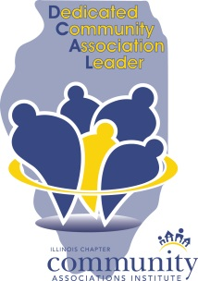
Name of Property Manager
Property Manager
Community Name Here

